**LOGIC GATES SIMULATOR SYSTEMS**

**A SEMINAR PAPER BY**

**IGBOEKWULUSI FRANKLIN CHINEDU**

**2017364022**

**DEPARTMENT OF ELECTRONIC AND COMPUTER ENGINEERING**

**NNAMDI AZIKIWE UNIVERSITY, AWKA**

**JANUARY 2023.**

**LOGIC GATES SIMULATOR SYSTEMS**

**A SEMINAR PAPER BY**

**IGBOEKWULUSI FRANKLIN CHINEDU**

**2017364022**

**IN PARTIAL FULFILMENT OF THE REQUIREMENTS FOR THE AWARD OF BACHELOR IN ENGINEERING (B.ENG)**

**DEPARTMENT OF ELECTRONIC AND COMPUTER ENGINEERING NNAMDI AZIKIWE UNIVERSITY, AWKA**

**JANUARY 2023.**

# **CERTIFICATION PAGE**

The seminar work “Logic gates Simulator Systems” was carried out by me under the supervision Engr. Dr. Kenneth Akpado and has not been submitted in part or full to this university or any other institutions for the award of a degree.

Igboekwulusi Franklin Chinedu Date

# **APPROVAL PAGE**

This is to certify that this seminar paper written by ”Igboekwulusi Franklin Chinedu” with registration number 2017364022 has been supervised and approved by the Department of Electronics and Computer Engineering, Nnamdi Azikiwe University Awka by:

Engr. Dr. Kenneth Akpado Date

(Supervisor)

Engr. Dr. Kenneth Akpado Date

HOD, ECE Department

**DEDICATION**

I dedicate this report to the Almighty God for his faithfulness and grace upon my life and my family for their maximum support in my academic pursuits.

**ACKNOWLEDGEMENT**

My profound gratitude goes to God almighty and my wonderful parents for always being there for me.

My special thanks go to my supervisor Engr. Dr. Kenneth Akpado, the H.O.D of the department Engr. Dr. Kenneth Akpado and all the wonderful lecturers in the department of electronics and computer engineering for their intensive lectures and maximum support both academically and morally

I would also like to acknowledge all the lecturers in Electronics and computer Engineering and Electrical Engineering whose lecturing since my first year gave me the adequate knowledge needed to carry out this seminar.

And also, I would also like to acknowledge all the non-academic staff and technologist(s) of The Electronics and Computer Engineering department for their support especially Engr. Okafor Tyndale and Engr. Asogwa Ekene for their assistance.

**ABSTRACT**

Logic gate simulator systems are computer programs that allow users to design and simulate digital logic circuits. These systems provide a graphical user interface (GUI) for designing and simulating logic circuits, allowing users to create, edit, and debug their designs. The GUI typically includes a library of logic gates, such as AND, OR, NOT, NAND, NOR, XOR, and XNOR gates. Users can also add custom components to the library. The simulator then simulates the circuit's behavior in real-time and provides visual feedback on the circuit's operation. This allows users to quickly identify errors in their designs and make corrections before committing them to hardware. Logic gate simulator systems are used by engineers in the design of digital logic circuits for embedded systems and other applications.

**Table of content Page**

Title page ii

Certification page iii

Approval page iv

Dedication v

Acknowledgement vi

Abstract vii

Table of content viii

List of figures ix

SECTION ONE: INTRODUCTION 1

* 1. Background of study 1

1.1.1 Brief history of logic gates simulators 2

SECTION TWO: DESIGN, TYPES AND EXAMPLES OF LOGIC GATE SIMULATOR SYSTEMS 4

2.1 Design of logic gate simulators systems 4

2.2 Types of logic gate simulator systems 5

2.3 Examples of logic gate simulator systems 5

SECTION THREE: ADVANTAGES AND DISADVANTAGES OF RENEWABLE ENERGY 9

3.1 Advantages of renewable energy 9

3.2 Disadvantages of renewable energy 11

SECTION FOUR: CONCLUSION 12

REFRENCES 13

**LIST OF FIGURES**

Figure1: Diagram showing a design of a logic gate simulator system. Page 4

Figure 2: Diagram showing the different types of digital logic gates Page 6

Figure 3: diagram showing solar power generation Page 7

**SECTION ONE: INTRODUCTION**

* 1. **Background** **of** **study**

Logic Gate Simulator is an open-source tool for experimenting with and learning about logic gates. The simulator tool was originally designed for CIS students at [South Puget Sound Community College](http://www.spscc.ctc.edu/) but is free for anyone to use and modify under the GPL(General Public License) v3. Logic Gate Simulator is written in C#/WPF using .NET 4 [1]

Logic gate simulator systems are computer programs that allow users to simulate the behavior of logic gates. They are used to design and test digital circuits, and can be used to teach basic logic concepts. Logic gate simulators typically provide a graphical user interface (GUI) that allows users to create and manipulate logic gates, as well as simulate their behavior. The GUI usually includes a library of logic gates, which can be dragged and dropped onto the workspace. The user can then connect the gates together to form a circuit, and then run simulations to see how the circuit behaves under different input conditions.

* + 1. **Brief History of Logic Gate Simulators**  
       Logic gate simulators have been around since the early days of computing. The first logic gate simulator was developed in the 1950s by IBM for use in their computers. This simulator was used to test and debug logic circuits before they were implemented in hardware.

In the 1970s, the first commercial logic gate simulators were released. These simulators allowed users to design and simulate digital circuits on their personal computers. They also allowed users to create custom logic gates and simulate them in real-time.

Since then, many different types of logic gate simulators have been developed, including those for educational purposes, professional engineering applications, and even gaming applications. Today, there are a variety of free and commercial logic gate simulators available for use on both desktop and mobile devices.[2]

**SECTION TWO: DESIGN, TYPES AND EXAMPLES OF LOGIC GATE SIMULATOR SYSTEMS**

**2.1 Design of a logic gate simulator**  
A logic gate simulator is a computer program that allows users to simulate the behavior of logic gates. It is designed to help students and engineers understand how logic gates work and how they can be used in digital circuits.

The design of a logic gate simulator should include a graphical user interface (GUI) that allows users to easily create and manipulate logic gates. The GUI should also provide an easy way for users to connect the inputs and outputs of the logic gates.

The GUI should also provide an easy way for users to view the output of the circuit as it changes with different inputs.

The simulator should also include a library of pre-defined logic gates, such as AND, OR, NOT, NAND, NOR, XOR, etc., so that users can quickly create complex circuits without having to manually define each gate. The library should also include more advanced gates such as flip-flops and multiplexers.

The simulator should also include a simulation engine that can accurately simulate the behavior of the circuit based on its inputs and outputs. This engine should be able to accurately simulate both digital and analog signals so that users can accurately test their designs before building them in real life.

Finally, the simulator should include debugging tools so that users can easily identify any errors in their designs or simulations. These tools could include breakpoints, watchpoints, trace points, etc., which allow users to pause or step through their simulations in order to identify any issues with their designs or simulations.

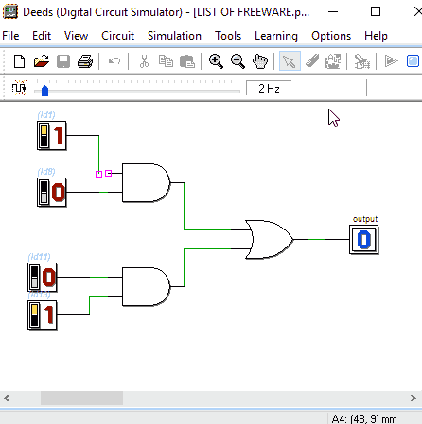

Figure 1 diagram showing a design of a logic gate simulator system.

**2.2 Types of logic gate simulator systems**

We have 3 basic types of logic gate simulator systems which includes:

1. **Digital Logic Gate Simulator**: A digital logic gate simulator is a software program that allows users to design and simulate digital logic circuits. It typically includes a library of logic gates, such as AND, OR, NOT, NAND, NOR, XOR and XNOR gates. The user can then connect these gates together to create more complex circuits.

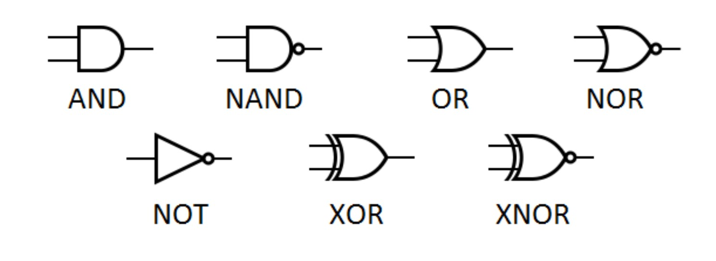

Figure 2 diagram showing the different types of digital logic gates.

1. **Analog Logic Gate Simulator**: An analog logic gate simulator is a software program that allows users to design and simulate analog logic circuits. It typically includes a library of analog components such as resistors, capacitors and transistors. The user can then connect these components together to create more complex circuits.
2. **Programmable Logic Gate Simulator**: A programmable logic gate simulator is a software program that allows users to design and simulate programmable logic circuits. It typically includes a library of programmable logic devices such as FPGAs (Field Programmable Gate Arrays) and CPLDs (Complex Programmable Logic Devices). The user can then connect these devices together to create more complex circuits.

**2.3 Examples of logic gate simulator systems**

Here are 4 examples of logic gate simulator systems which includes:

1. **Logisim:** Thisis an educational tool for designing and simulating digital logic circuits. With its simple toolbar interface and simulation of circuits as you build them, it is simple enough to facilitate learning the most basic concepts related to logic circuits**.** [3]

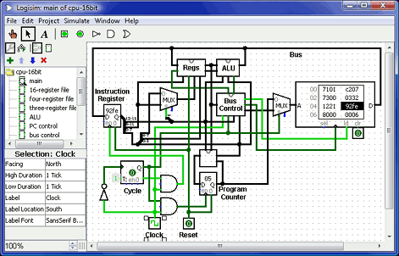

Figure 3 Screen shot of Logisim 2.7.0

**2.4 Solar Power**This is a system where solar panels convert sun rays into direct current. The panels have many solar cells which absorb the rays of the sun and generate direct current. Using an inverter, the direct current gets converted into AC current for use at homes, offices, schools etc.

The power is collected using solar, or photovoltaic (PV), cells made from silicon or other materials. These cells transform sunlight into electricity and can power anything from the smallest garden light to entire neighborhoods.

Rooftop panels can provide power to a home, while community projects and solar farms that use mirrors to concentrate the sunlight can create much larger supplies. Solar farms can also be created in bodies of water, called ‘floatovoltaics’ these provide another option for locating solar panels. [6]

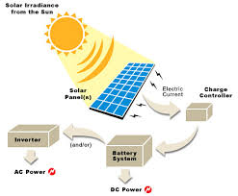

Figure 3 diagram showing solar power generation

**2.5 Geothermal Power**Geothermal power is clean and sustainable. It relies on hydrothermal resources – hot water and steam – for power production. Technologies in use include flash steam power stations and dry steam power stations.

Geothermal energy uses the heat trapped in the Earth’s core which is created by the slow decay of radioactive particles in rocks at the center of the planet. By drilling wells, we are able to bring highly heated water to the surface which can be used as a hydrothermal resource to turn turbines and create electricity. This renewable resource can be made greener by pumping the steam and hot water back into the earth, thereby lowering emissions. [7]  
  
The availability of geothermal energy is closely tied to geographical location, with places such as Iceland having an easily reached, ready supply of geothermal resources.

**2.6 Hybrid Power Systems**

A hybrid power usually consists of two or more renewable energy sources used together to provide increased system efficiency as well as greater balance in energy supply.  
This is a new off-grid technology that features both a wind turbine and solar power system. the combination of the two sources, power generation is doubled. The system is very efficient and ensures that power is available at all times.

**SECTION THREE: BENEFITS AND DISADVANTAGES**

**OF RENEWABLE ENERGY**

**3.1 Advantages of Renewable Energy**

* A Fuel Supply That Never Runs Out  
  As the name suggests, renewable energy is created from sources that naturally replenish themselves – such as sunlight, wind, water, biomass, and even geothermal (underground) heat. [8]  
    
  Unlike the mining of coal, oil, and natural gas – which requires extensive networks of heavy machinery, processing stations, pipelines, and transportation – renewables convert natural resources directly into electricity. And while many fossil fuels are becoming harder and more expensive to source – resulting in the destruction of natural habitats and significant financial losses – renewable energy never runs out.
* Zero Carbon Emissions  
  Perhaps the most significant benefit of renewable energy is that there are no greenhouse gasses or other pollutants created during the process. Whereas coal power plants create around [2.2](tel:2.2) pounds of CO2 for every kilowatt-hour of electricity – solar panels and wind turbines create none at all.  
    
  As we race to decarbonize our world and embrace energy sources that don’t contribute to global warming, renewables are helping to provide us with emission-free energy, heat, cars, and even air travel.
* Cleaner Air and Water  
  Burning fossil fuels to generate electricity does far more than warm the climate; it also contaminates the air we breathe and the water we drink.

Coal power stations, for example, release high volumes of carbon dioxide (CO2) and nitrous oxide (N2O) directly into the atmosphere – two of the most potent greenhouse gasses. But in addition, they also emit mercury, lead, sulfur dioxide, particulates, and dangerous metals – which can cause a host of health problems ranging from breathing difficulties to premature death. Fossil fuel electricity can also contaminate waterways, both from air pollution that falls to the ground during rain, and waste materials created during the production process.

On the other hand, renewable energy creates no pollution, waste, or contamination risks to air and water.

* A Cheaper Form of Electricity  
  With the rapid growth of renewable energy over the last ten years, solar and wind power are now the cheapest sources of electricity in many parts of the world. In the United Arab Emirates – an area well-known for its abundant land and sunny weather
* Renewable Energy Creates New Jobs  
  With an increasing focus on global warming and many governments setting ambitious carbon-reduction goals, one of the surprising renewable energy advantages is that it has quickly become a major source of new job growth.

**3.2 Disadvantages of Renewable energy**

* Higher Capital Costs  
  While renewable energy systems need no fuel and can deliver substantial long-term savings, their up-front costs can still be prohibitive.
* Electricity Production Can Be Unreliable  
  Renewable energy systems rely on natural resources such as sunlight, wind, and water, and therefore, their electricity generation can be as unpredictable as the weather. Solar panels lose efficiency on cloudy days, wind turbines aren’t effective in calm weather, and hydropower systems need consistent snow and rainfall to maintain reliable production.  
    
  At the same time, when renewable systems produce too much energy, they risk overloading the grid and causing major problems for network operator.
* Energy Storage Is a Challenge  
  Due to the intermittent nature of renewables, they need forms of energy storage to capture and release electricity in a consistent and controlled way.
* It’s Impacted by Environmental Conditions  
  The efficiency of renewable energy systems also depends on their location and surrounding environment. For example, wind turbines are only effective in large, open areas with strong and consistent wind, which limits their viability to specific regions.  
    
  And while solar panels generate some electricity even on cloudy days, they are most productive in locations with consistently bright and sunny climates.

**SECTION FOUR: CONCLUSION**

The ongoing concerns about climate change have made renewable energy sources an important component of the world energy consumption portfolio. Renewable energy technologies could reduce CO2 emissions by replacing fossil fuels in the power generation industry and the transportation sector.

Because of some negative and irreversible externalities in conventional energy production, it is necessary to develop and promote renewable energy supply technologies and demand for renewable energy.

Power generation using renewable energy sources should be increased in order to decrease the unit cost of generation. Energy consumption depends on several factors including economic progress, population, energy prices, weather, and technology.

References:

[1] Steve Kollmansberger, “- Logic Gates Simulator” in *kolls.net/gatesim,* united states, 2009.

[3] “- Logisim” in  *cburch.com/logisim,* 2014.